**MINI PROJECT – II**

**(2019-20)**

# FURNITURE WEBSITE

# 

**MID-TERM PROGRESS**

**REPORT**



**Institute of Engineering & Technology**

**Team Members**

Shikha Saini

(171500315)

Sanket Goyal

(171500291)

Shivam Mehrotra

(171500321)

Prafullit Shukla

(171500222)

Supervised By

**Mr. Pankaj Kapoor**

**Technical Trainer**

**Department of Computer Engineering & Applications**

**INTRODUCTION**

Furniture Website is a complete web application which allows users to check for various furniture available at the online store and purchase online. The project consists of list of furniture products displayed in various models and designs. The user may browse through these products as per categories.

Furniture website gives you facility of booking any type of furniture. The system is made so that customer will not have to come to us to buy furniture.

The project is useful for the manager of the company as it helps them to search the data faster than existing system, to get customer record easily and report of the customer, payment, etc are generated as per requirement.

**PROJECT STATUS**

We have made the front page of the Tours And Travel Website which consists of a serach page and a feedback column or query column.We have showed some featured destinations. We have made a search bar, the customer can search his travel destination.

* We have made a Navbar consisting of Home, Catalog, Signup and Login tab.

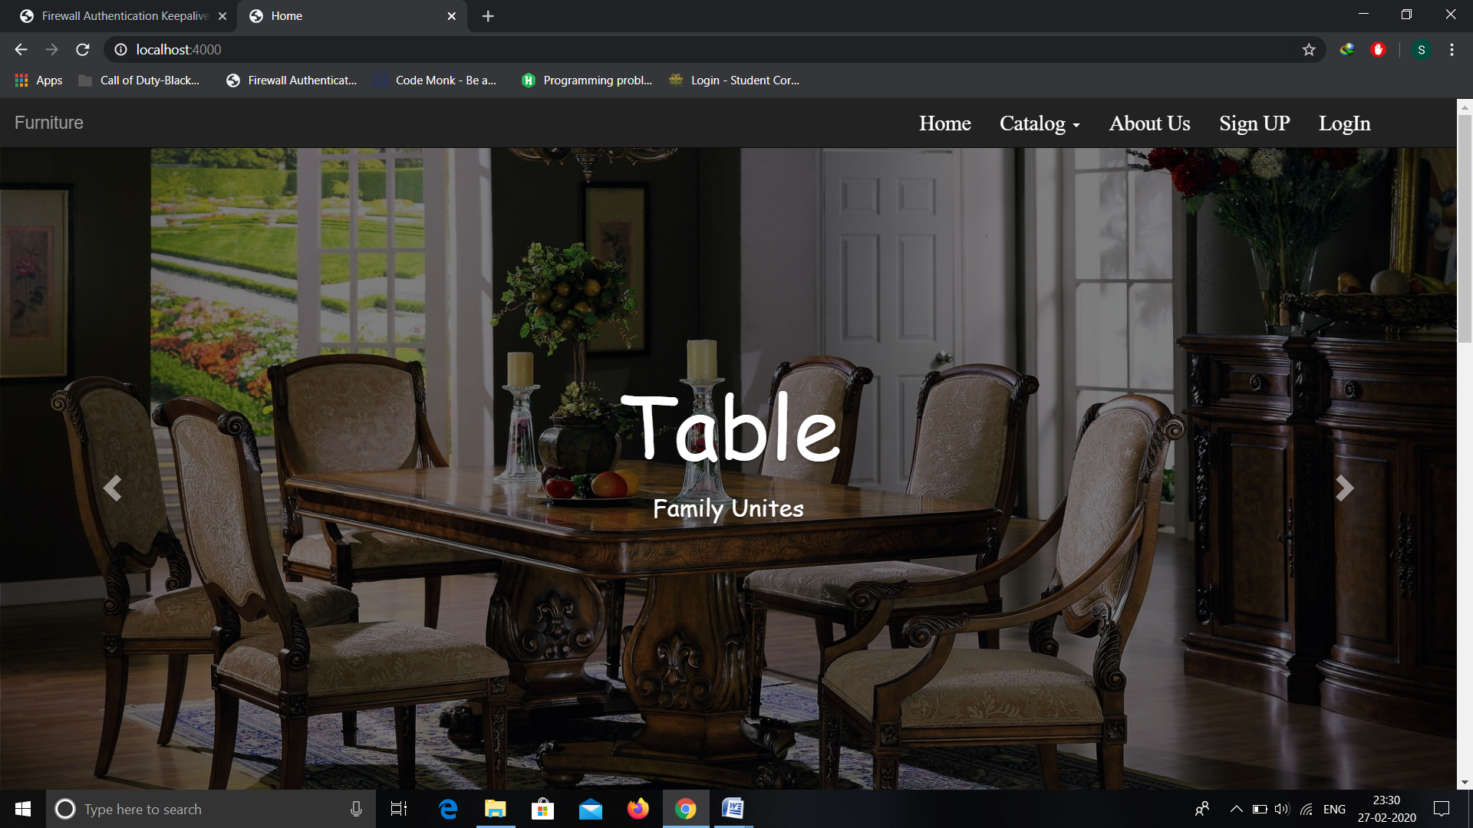

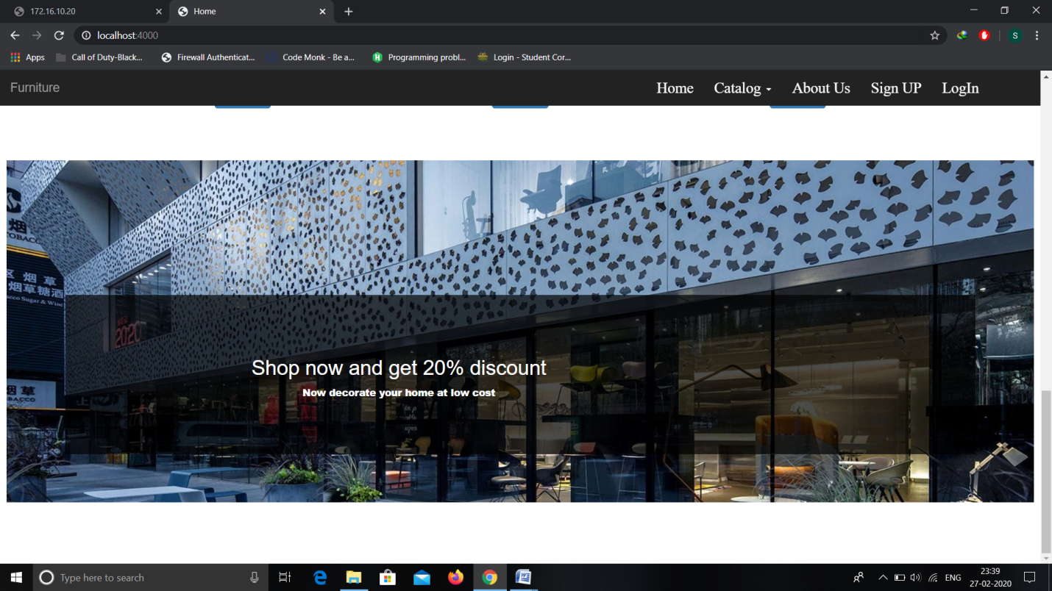

* We have made a section for best selling products, where a customer can see which products are best sold at our website.

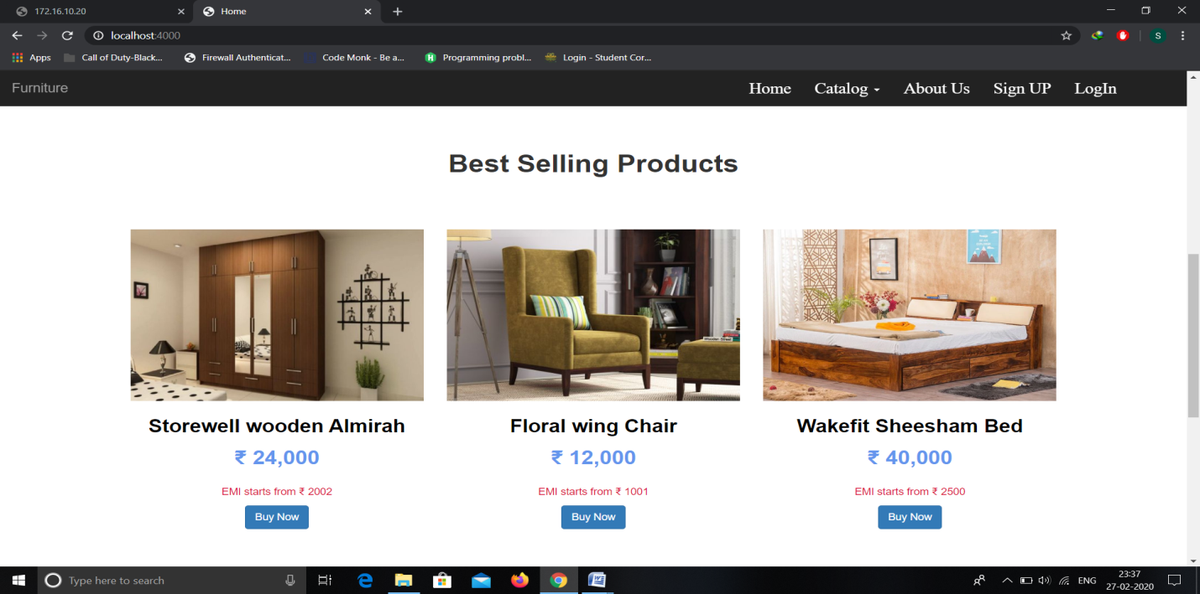

**SUMMARY**

We know that in recent times, people like to visit different shops to search a furniture of his/her choice.Our website will help in accessing the information related to the furniture and its type with great ease.

The main objective of the Furniture Website is to manage the details of Product Bought, Phone no., E-mail ID and Customer Support . The purpose of the project is to build a web application to reduce the manual work for searching the furniture of his/her choice, furniture types, customer queries etc. It tracks all the details about the product bought.

**PROPOSED TECHNOLOGIES**

* MongoDB:MongoDB is a No SQL database with the scalability and flexibility that you want with the querying and indexing that you need.
* Express**:** Express.js is a node.js web application server framework, which is specifically designed for building single-page, multi-page, and hybrid web applications.
* Node.js: We are using node.js as backend technology. It is an open source cross platform javascript runtime environment server environment.
* HTML5 :For user interfaces.
* CSS3: For making interfaces more attractive and stylish.
* Bootstrap 4**:** For make website responsive.

**FUTURE PLANNING**

In future we will implement login and registration module, we will also implement internal hyperlinking in each page.We will show information of those destinations which are available at our websites.

Customer will be able to choose package by itself and will pay for it. We will make a databse for it and a design a logo for it. We will make a webpage showing customer details.

**Github Repository**

https://github.com/Sanketgoyal26/mini_project_II